

Come and talk to Parkside and Oakbank Beckfoot about transition

Mrs Jones will be available to talk about any Special Educational Needs concerns or questions you may have

Our School Nurse, Karen will be available until 5:30 on Monday and 6:00 on Thursday

Mrs Hartley will be available to discuss ParentPay, Explorers and answer administrative questions

Come and talk to Mrs Dyson about Social and Emotional issues and find out about The Nest

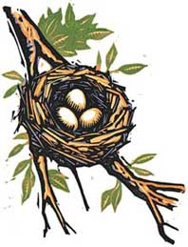

Find out about how we teach maths in school and how you can help your child 

Refreshments will be served by Friends for a small donation to raise money for school

Any good quality uniform which is un-named and un-claimed will be washed and ironed and available to buy for a small donation

Your children’s maths and English books will be out for you to look at



We will have an information stall about online safety and Mr Parkin will be available to talk to about keeping your children safe online



Oxenhope C of E Primary

Parents and Carers Evenings

**We have lots of things happening at our parents and carers evenings this year:**