What a wonderful week in Reception!
Here are some of the wonderful things we have been learning in reception over this week.
This week was Mental Health Awareness week in our school where we have been understanding more about what makes us special and unique. In Reception our focus has been on Me and My Friends.

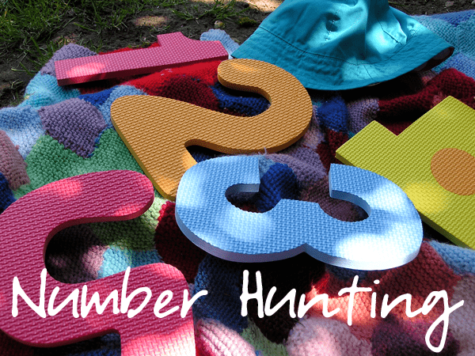
In maths we have been busy learning about subtraction, ordering numbers, looking at place value, deciding on 1st,2nd,3rd,4th, and 5th numbers. We have really got to grips with numbers to 20 and beyond. Our next steps are to be able to use our knowledge of these numbers to solve problems. Thank you to all the children who completed their number hunt challenge this week.
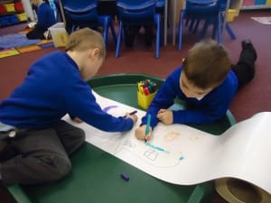
Our children have also been completing lots of writing this week about friendship and what makes a good friend. They have been creating cards and letters for their friends to let them know how special they are. To encourage writing at home give your child a job to do, such as making a shopping list, writing a card or letter or creating a book all about a favourite toy. Have writing equipment, clipboards and paper available and your child won’t be able to resist!
Outside the children have been creating friendship bridges and problem solving about how to cross the bridge. This allowed the children to learn about cooperation and developed their thinking, speaking and listening skills.

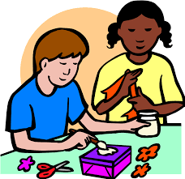
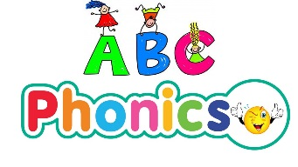
In phonics we have been learning, igh, oa, oo (look), oo (moon) please spend some time with your child identifying these sounds in words you see in books or around your home. We have also sent home the phase 3 high frequency words for you to practise at home.
The children have loved creating art work of their friends this week. We have been looking at famous art of friends and have mixed colours in paint, used pencil crayons, taken photos and tried to create accurate images of faces.
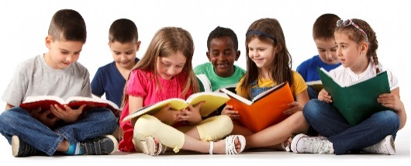
Our reading this week has focused around the story Little Beaver and the Echo, which is about friendship. The children have used this as a ‘spring board’ for their learning. You should have a new reading book to read with your child over the holidays. Why not visit the local library and find out about books?
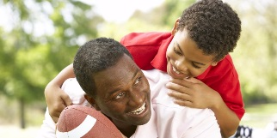
We have sent home our Reception Holiday Challenges. This features 20 things you as a family might like to do. It also includes some writing and maths challenges. Please remember to read together and look at the phonics sheets.
On Tuesday we enjoyed our first class assembly where the children performed so well. We have copies of the poems available. If you would like copies please speak to reception staff.
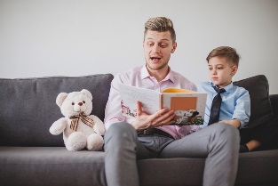
If you would be interested in becoming a parent reader please can you leave you details at our school office and Mrs Jones will be in touch.

Thank you,
Mrs Jones, Mrs Truesdale, Mr Naylor and the Reception Team

Reception Home Challenge
20 things to do in the holidays !
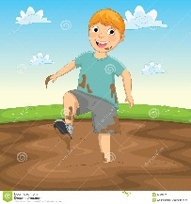
How many can you do?
- Play in the mud
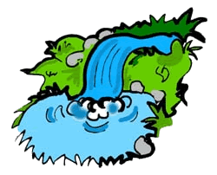
- Visit a waterfall
- Sing a new song

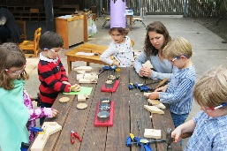
- Gather things you find in the woods and make a model
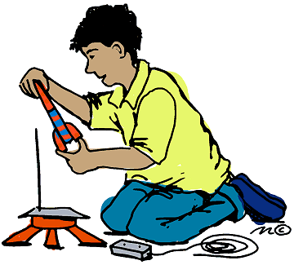
- Make a rocket
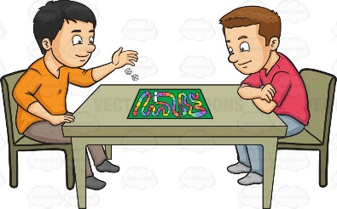
- Play a new game with a friend
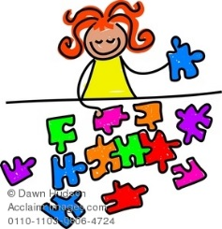
- Make a jigsaw
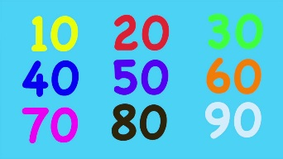
- Count in 10s
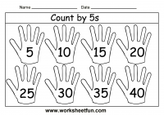
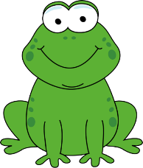
- Count in 5s

- Find out about an animal
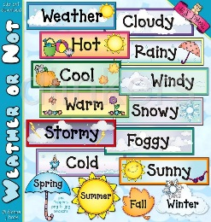
- Make a weather chart
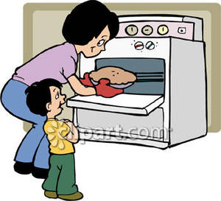
- Bake bread
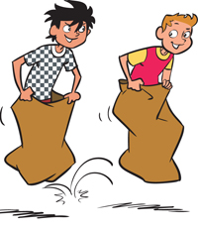
- Have a race
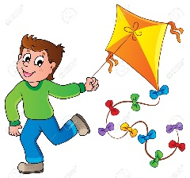
- Fly a kite
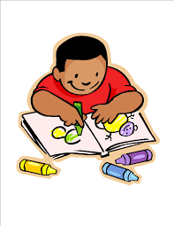
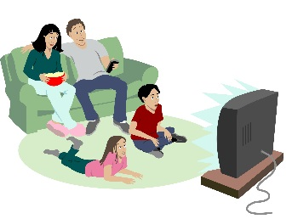
- Draw your house

- Watch a film with a family member
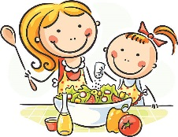
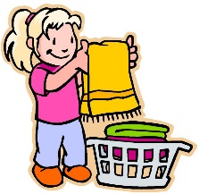
- Make tea

- Help around the house
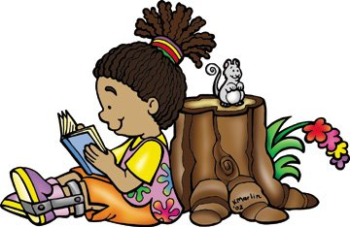
- Learn a poem

- Learn about money

